Simply Good Works
Presents

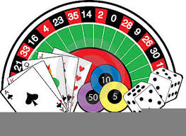
“Casino Royale”
September 7, 2019

- Single Tickets - Early Bird: $65.00 : # of Tickets _________Total____________
  - Free $50. Chip Voucher with each ticket purchased.
- Std. Tables for 8 – Early Bird @ $520.00 : # of Tables __________Total____________

- Dance Floor – Premium Tables (Table for 8) @ $650.00 …..# of Tables_______
  - Includes 8 free Door Prize tickets
- Donate a ticket for a Wounded Warrior and his/her companion dog…
Single Tickets: $75.00 # of Tickets _________Total___________

I would like to Under-write one of the following items:
 | Dinner | $2,500
 | Bartenders/Security | $1,000
 | Music | $500

I am unable to attend but would like to donate the following:
 | Level 1 | $50
 | Level 2 | $100
 | Level 3 | $250
 | Level 4 | $500
 | Other

Program Ads Available:
 | Quarter Page | $160
 | Half Page | $275
 | Full Page | $500

Make checks payable to: Simply Good Works, Inc. - call: 408 840-1694 for information
Mail to: 745 S. Daniel Way, San Jose, CA 95128
Credit cards are accepted on our website – www.SimplyGoodWorks.org
NOTE: All seats are reserved and all tickets will be mailed 2 weeks in advance of event

